**PROTOTYPE & TESTING**

Gold Rush

Victor GANTER – 2926840

Melchior GARRIGUES – 2927207

Valentin FEREY – 2926392

Galdan MOULINNEUF – 2927686

Table of contents

**1 Introduction****2**

**2 Methodology****2**

**3 Evolution****3**

3.1 Early ideas & refining 3

3.2.1 Early Prototypes 4

3.2.2 Early Prototypes testing (Technical testing) 5

3.3.1 Refined Prototype 5

3.3.2 Playtesting 6

3.4 Last Prototype 6

3.5 Final testing Question & Feedback : 7

# 

# 

# 

# 1 Introduction

Gold Rush, take a lot of inspiration from risk, but add mechanics to make the core gameplay more interesting more strategic. The fights have no random factor, and the fights are based on 3 types of units. Each unit beat another type in a rock-papers-scissors manner. We also introduce ressources, who give a different weight to each units, and introduce the resource deny strategy.

# 2 Methodology

To design & test our prototype we have follow an agile methodology. Each time we have designed or refined our prototype, we have done some test who lead to feedback, and after we return to the first step.



# 

# 

# 3 Evolution

### 3.1 Early ideas & refining

The Early ideas introduce gold, who is a resource. Gold can be trade at a 1:1 , and produce mercenaries, so gold, is very important, and player must fights for it.

Early prototypes introduce maps, where gold is in the center, and can be attacked by multiple terrains, so it's hard to defend.

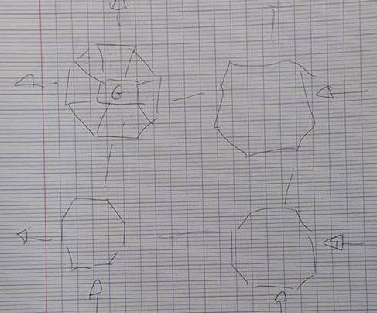

Here on this handmade shema, ideas, how to make gold important.

In this schema, we were thinking that each island can be self sufficient, providing each type of resources (to avoid players to be stuck without a certain type of resource).

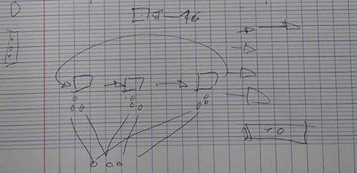

Here is a Schema of how the different units will interact between each other, and how we produce them (what resources does they cost).

### 3.2.1 Early Prototypes

Instead of prototyping all the maps by ourself, we take a map on a risk website, and adjust it to our needs.

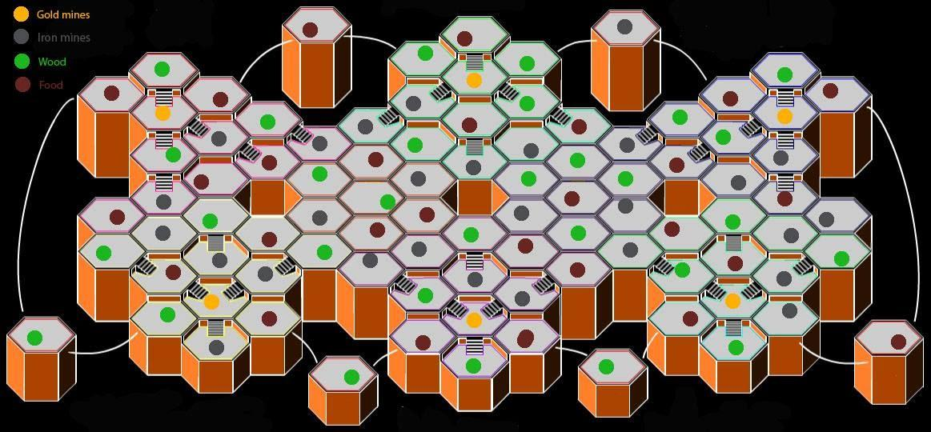

We put resources on each tile, add gold in center places, and try to balance resources, in the philosophy presented before (zones can be self sufficient). Units & resources templates were created:

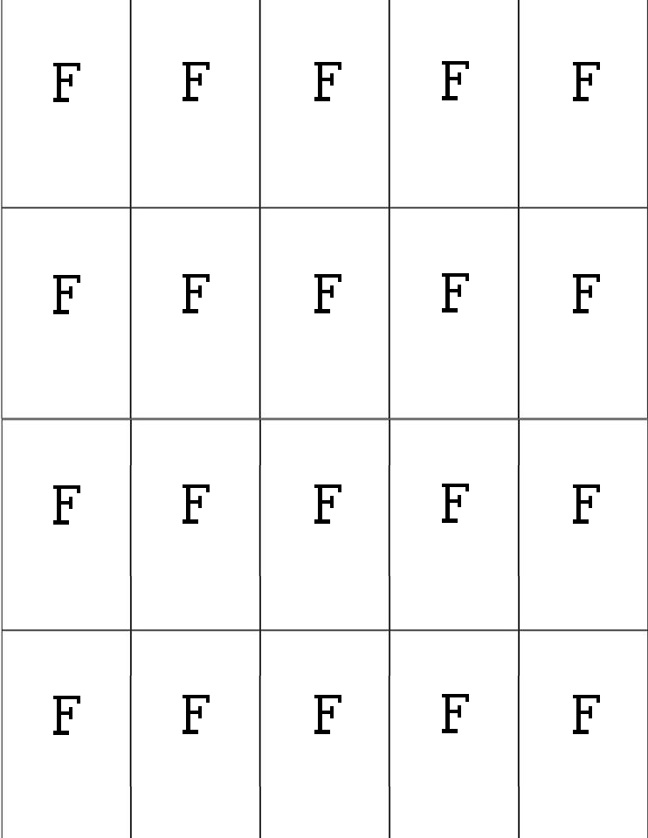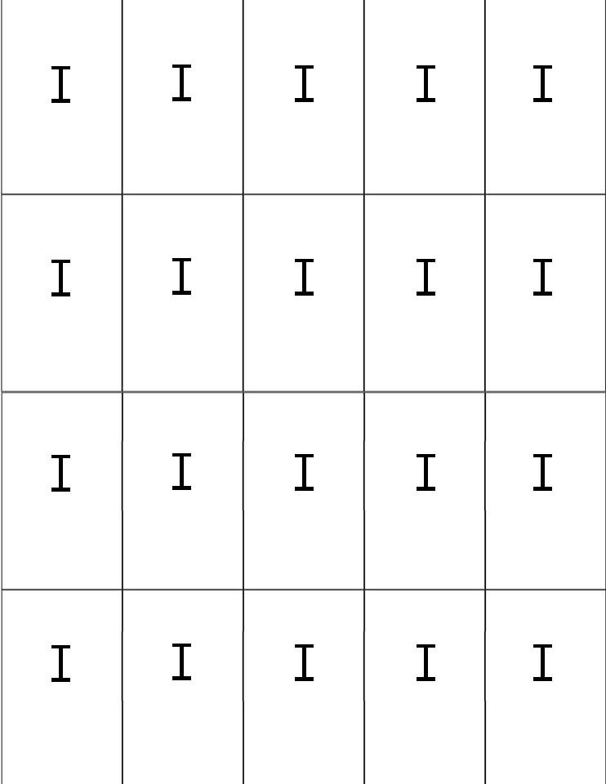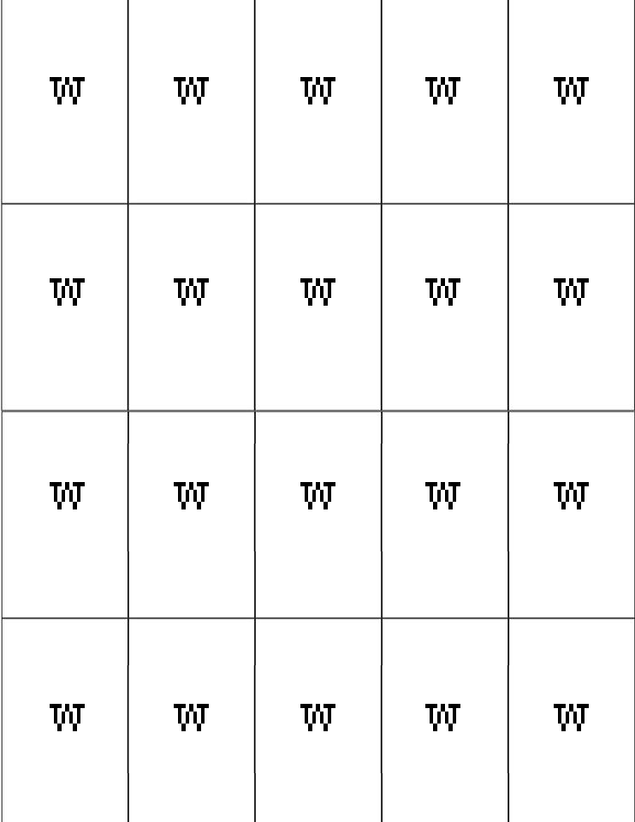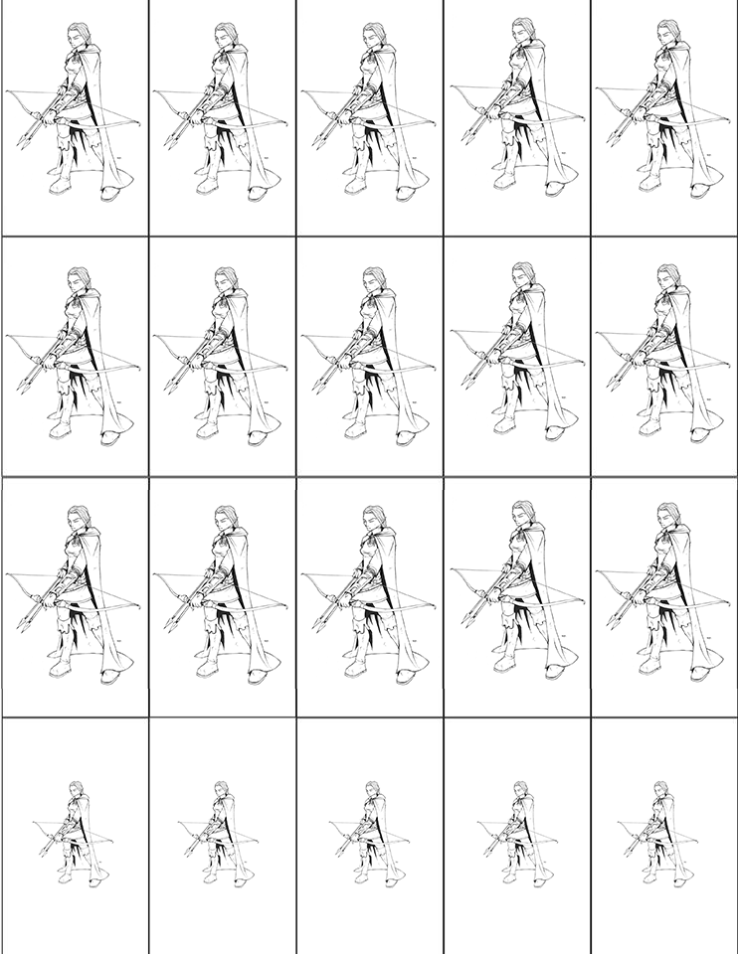

We also modificate after some thinking how the gold works, instead of buying mercenaries with it, gold instead boost units in fights. Gold has also become a winning condition.

Basics rules were put in place, to begin technical testing.

### 3.2.2 Early Prototypes testing (Technical testing)

Technical testing were done with multiple number of players, and the overall feedback show that

* Rules where not correctly defined, the beginning of the game was vague
* In the case of 2 players, the game was slow to develop, and take too much time to expand.
* Current Fight System was confusing(how units engage others units, how their strength against each other apply, how player use their gold to “boost”)
* Unit cost was too high, meaning player taking time to expand
* Too much gold territories, lead in some games, to player to not expand, and try to win with only gold.

### 3.3.1 Refined Prototype

To address the precedent issues, we have made several changes to the game.

* Since expanding take time, we remove the conditions, that a player, to control a territory must leave at least one unit on it. Unit cost was also lowered, each units costing only of 2 types of resources, instead of 3.
* Fight System was completely reworked, instead of all units fight at the same time (who was confusing), we put in place a turn based system, where each player say which of his unit will attack, one of the other player unit. Taking into account the strength/weakness of his units.
* Gold territories was removed, only two gold territories are in the map now.
* To also make the game more dynamic, we reduced the workers to only 3, and change the way to earn resources. Now for each territory you control, you gain one resource of his corresponding type, Except gold. Workers now can be used to gain additional resources, but they are also the only way to gain Gold.

### 3.3.2 Playtesting

Some sessions of playtesting were done, and the overall feedback show that :

* Map is still too big for low number of players
* Gold take too much of time to get

### 3.4 Last Prototype

* Gold Now can be stolen by the winner of a fight (one by win)
* Changed Map, Now there is 2 versions in function of the number of players

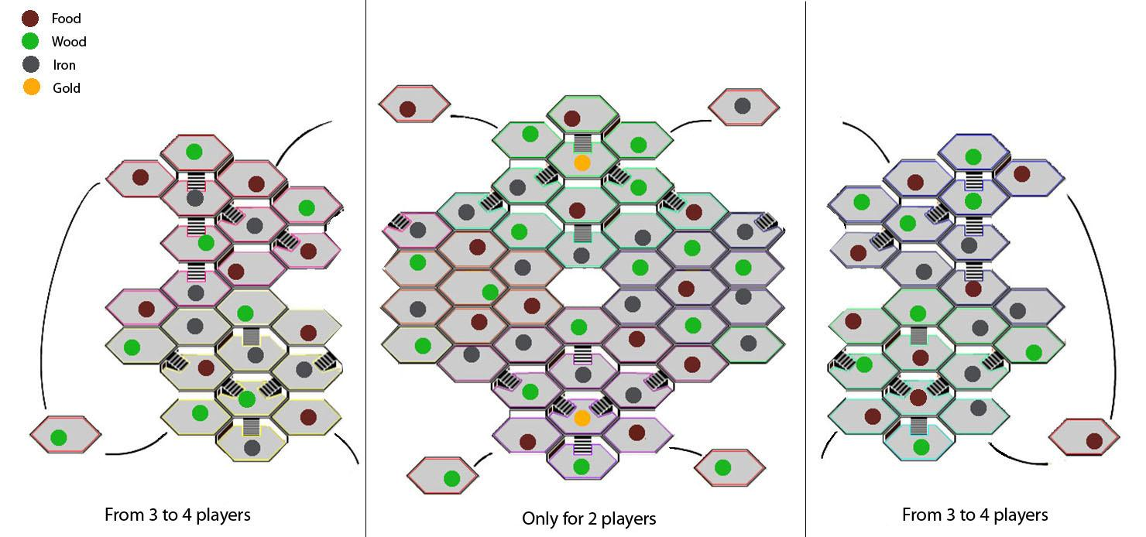

Here is an image of the new Map

### 3.5 Final testing Question & Feedback :

1. Did the rules are clear and easy to understand ?

*Yes the rule script was clear, we didn’t need to ask for help but just too many informations to keep in mind during the game so we always needed to refer to it.*

1. Did you get the strategic part of the game? Did you like it?

*Of course ! The strategic part is one of the funniest thing in this game, there is a lot of different way to win and the cool thing is that you don’t really need to focus on gold to win cause if you take good resources and good armies it become easy to stole everything to your opponents.*

1. Did the game seems you balance?

*For the game we played it was, it was just a question of logic and strategy but maybe needed to be played few times more to answer this question*.

1. Did you find the costs of the resources too much or less important?

*I don’t know, sometimes at the beginning it was, it difficult to have a good army but after 5 or 6 rounds you can have all what you want so...*

1. Did you find the game too long?

*Yes a bit longer. Maybe because the strategy make us meditate a lot of time. And the prototype is not really playable because we always needed to take notes*.

1. Did you enjoy playing the game or was it boring?

*At the beginning it really looked like boring. To well understand how to play, how to start it take too much time and if you’re not patient it become boring. But in fact after few rounds when you start the strategy and to well handle the game logic it become really interesting and fun.*

1. How did you find the battles?

*The concept of the counter troops is quite good. Battles were balanced and you can have fun by doing yourself the animations. Seems correct in global.*